PHARMACY WEEK CELEBERATION 2017- PHARMA RALLY

THEME: KNOW YOUR MEDICINES-ASK YOUR PHARMACIST.

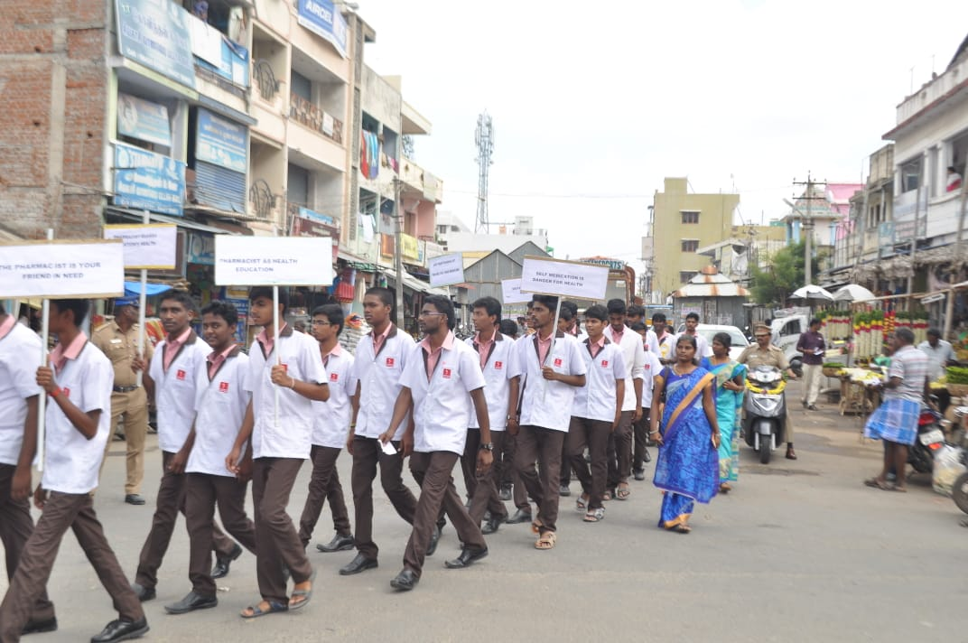

PHARMACY WEEK CELEBERATION 2022- PHARMA RALLY

THEME: PHARMACY OF THE WORLD - INDIA

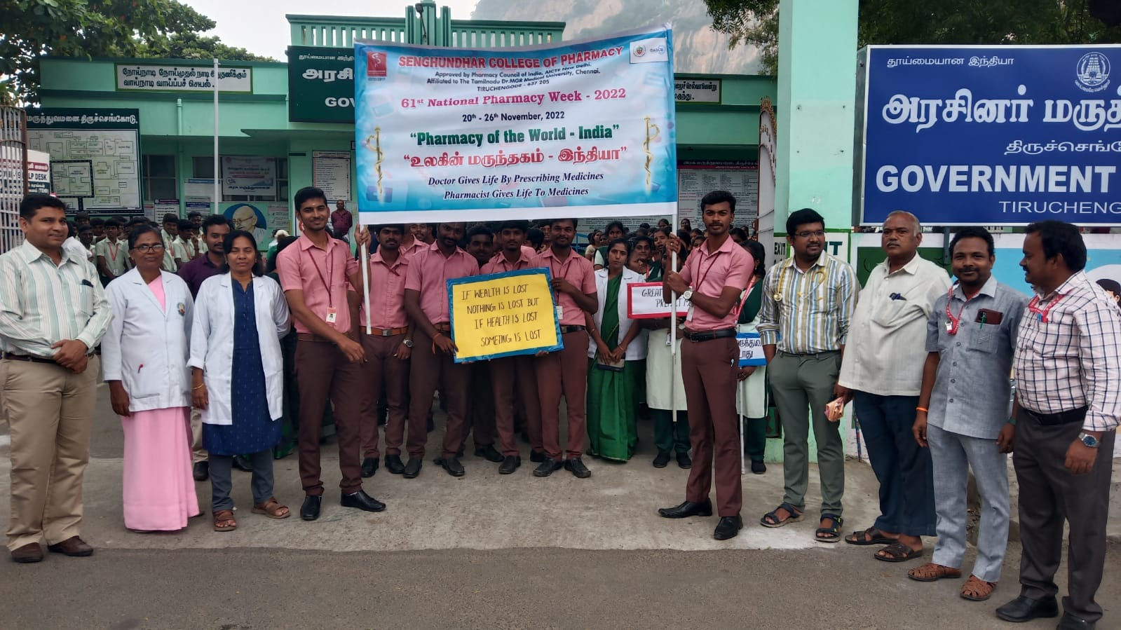

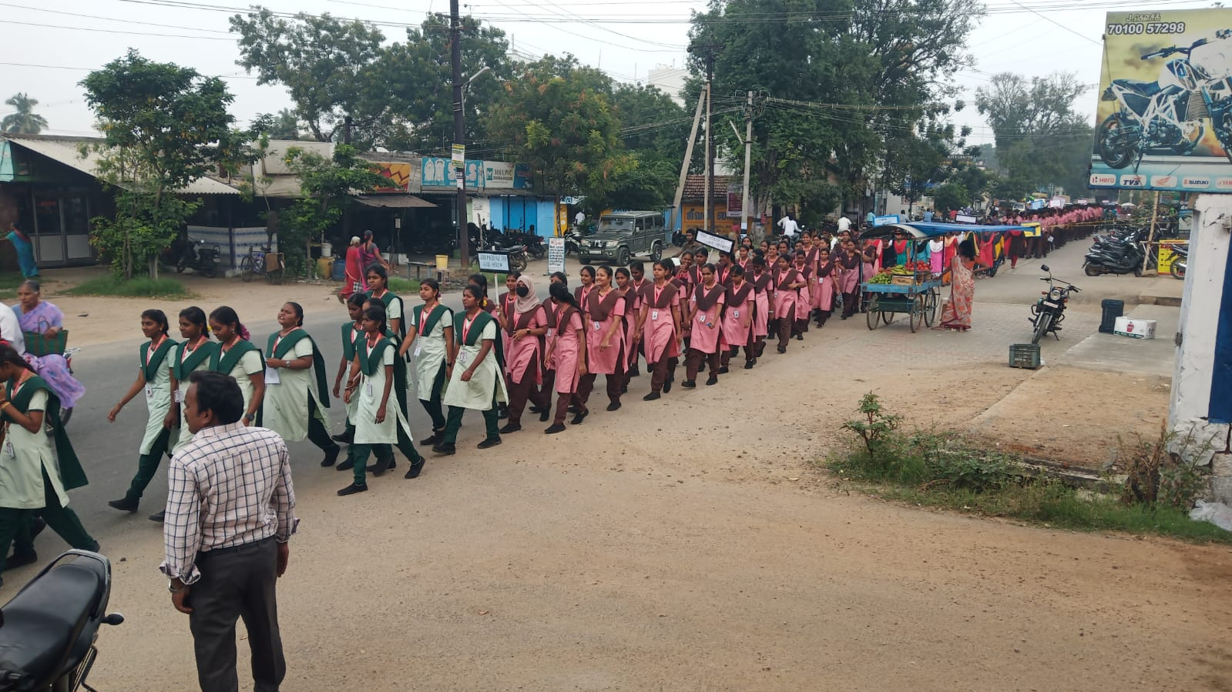

PHARMACY WEEK CELEBERATION 2023- PHARMA RALLY

THEME: PHARMACIST STRENGTHENING SYSTEM

